**สมิทธิภาพของการศึกษาคำศัพท์เฉพาะด้านในงานธุรกิจบริการ**

**จากการใช้คลังคำศัพท์ภาษาอังกฤษ**

**English for Service Sector Majors’ English Language Proficiency in Using ESP Vocabulary Corpus**

**Natthika Boonrasamee1\***

Songkhla Rajabhat University, Muang Songkhla, Thailand 90000

*E-mail: [natthika.bo@skru.ac.th](mailto:natthika.bo@skru.ac.th)

**บทคัดย่อ**

การศึกษาครั้งนี้มีวัตถุประสงค์ เพื่อวัดผลสัมฤทธิ์ของนักศึกษาสาขาวิชาภาษาอังกฤษงานธุรกิจบริการในการฝึกใช้คลังคำศัพท์ภาษาอังกฤษจาก BYU-BNC ในรูปแบบของห้องเรียนเสมือน Google Class จำนวนคำศัพท์ทั้งสิ้น 50 คำ คำศัพท์เหล่านี้เป็นการรวบรวมและเลือกสรรจากเนื้อหาของรายวิชาภาษาอังกฤษสำหรับงานโฆษณาและประชาสัมพันธ์ ภาษาอังกฤษสำหรับธุรกิจการบินและภาษาอังกฤษสำหรับอุตสาหกรรมการบริการ กลุ่มตัวอย่างเป็นนักศึกษาชั้นปีที่ 2 และ 3 จำนวน 53 คน ซึ่งได้มาจากกลุ่มตัวอย่างแบบการสุ่มแบบเจาะจง ด้วยความคำนึงถึงจริยธรรมในการวิจัยการขอความยินยอมจากกลุ่มตัวอย่างได้ดำเนินเสร็จสิ้นในสัปดาห์แรก เครื่องมือที่ใช้ในงานวิจัยประกอบด้วย 1) บทเรียนการใช้คำศัพท์เฉพาะด้านจากคลังคำศัพท์ในห้องเรียนเสมือน จำนวน 21 ชุดคำ และ 2) แบบทดสอบการใช้คำศัพท์เฉพาะด้านก่อนเรียนและหลังเรียน กลุ่มตัวอย่างทำข้อสอบก่อนเรียนในสัปดาห์ที่ 4 หลังจากนั้นทดลองเรียนชุดคำศัพท์ที่เลือกสรรจากห้องเรียนเสมือน Google Class เป็นระยะเวลา 10 สัปดาห์ ซึ่งกลุ่มตัวอย่างสามารถเข้าเรียนในบทเรียนซ้ำเพื่อทบทวนบทเรียนด้วยตนเองได้ จากนั้นจึงทำการทดสอบหลังเรียนในสัปดาห์ที่ 14 ค่าสถิติเชิงพรรณนาใช้แปรผลคะแนนการทดสอบก่อนเรียนและหลังเรียน พบว่า คะแนนที่ได้จากการทดสอบหลังเรียนการใช้คลังคำศัพท์มีระดับคะแนนสูงกว่าคะแนนก่อนการเรียนซึ่งแตกต่างอย่างมีนัยสำคัญทางสถิติที่ระดับ 0.05 การศึกษาครั้งนี้อาจเป็นแนวทางในการออกแบบชุดการเรียนการสอนในการพัฒนาการเรียนรู้คำศัพท์ภาษาอังกฤษของนักศึกษาในสาขาอื่นๆ และการจัดทำชุดอบรมระยะสั้นเกี่ยวกับภาษาอังกฤษเพื่องานบริการ

*คำสำคัญ:* คลังคำศัพท์ ภาษาอังกฤษเฉพาะด้าน งานธุรกิจบริการ อุตสาหกรรมบริการ

**Abstract**

This current study aimed to evaluate English for service sectors majors’ language proficiency in utilizing BYU-BNC (Brigham Young University-British National Corpus) in a virtual classroom [Google class]. Fifty words were compiled and selected from textbooks from three courses, namely, English for Advertisements and Public Relations, English for Aviation, and English for Hospitality Industry. A purposive sample was from both second- and third-year learners enrolled in the previous three courses. In terms of research ethics, a consent form was distributed amongst the subjects in first week. Research tools were 1) a twenty-one-set of vocabulary lesson related to English for specific purposes appearing in a form of the virtual class [Google class] in week four, and 2) a pre- and post- test about vocabulary bank. Prior to the main study, the pre-test was administered. Subsequently, the subjects were asked to study and review the lesson in the Google class. Then, the post-test was administered in week 14. The descriptive statistics were used. The results were that learners’ achievement in gaining insights into the set of vocabulary from the BYU-BNC corpus was high. There were also statistical differences between the pre- and the post-test scores at .05 levels. This current study could provide not only a set of pedagogical guidelines on vocabulary development for multidisciplinary learners but also a short course training in English vocabulary for specific purposes.

*Keywords:* English corpus, specific English purposes, service sectors, hospitality industry

**Rationale of the study**

Vocabulary is systematically comprised of at least three features such as forms, usages, and meanings (Coxhead 2011, Schmitt, 2002, Nation, 2001). To simplify this idea, these three tiers are essentially important to convey a certain meaning of one vocabulary. The vocabulary has a specific meaning depending on its context. Hence, the authenticity of the vocabulary effectively helps learners to gain an insight into that word/ phrase. A growing number of studies examines *how* vocabulary used in terms of how vocabulary is effectively used inside and outside class, or *what* trend of pedagogical perspective should be (e.g., Lu,2013, Newton, 2013). A simple answer of those two previous questions is to use an authentic context such as a short film dialogue (Csomay & Petrovic, 2012).

One approach to obtain a real meaning of English language in a variety of situations should rely on a large collection of a representative wordlist via English corpus. Corpus linguistics emphasizes to the study of patterns of the authentic language derived from the examples of language use in the real life and the data of those examples are stored electronically (Bunnett, 2013). Roughly, English corpus yields a language pattern and provides both a common and uncommon usage of a word in a specific register.

In terms of academic words depicted in English corpus, a presentation of lexicographical patterns has been illustrated in a form of concordance lines. Language data (data driven learning) provides access to language use in a variety of discourses. Subsequently, learners, themselves, could raise their linguistic awareness as well as develop their metacognitive skills (Cobbs & Boulton, 2015) when they explore the language data according to their preferences.

However, realising potential and great benefits of language data are challenging due to time constraint and a heavy load of data. Another problematic matter primarily depends on learner preferences that might result in effectiveness of DDL (Mitzumoto & Chujo, 2016). This current study, consequently, observed the use of language data by EFL (English as a foreign language) learners at a tertiary level attempting to boost their language performance, especially in English for specific purposes (ESP) vocabulary bank.

The following research question is addressed in this paper:

1. How do EFL learners recognise language data after exploring prescribe language lessons?

**Literature Review**

1. ESP as a context for BYU-BNC consultation

A great number of studies (e.g., Yoon, 2011, Perez-Paredesa, *et.al*., 2011) regards of helping EFL learners negotiating with amount of language data. A primary focus on strengthening vocabulary in specific purposes essentially needs unlimited-time, tips, and language tools. To save time and encourage the learners to access linguistics data at once, Benett (2013) guided how to consult English corpus as traditional classroom materials (corpus-influenced material) as follows:

- employing common lexical items in specific language patterns

- providing the most common contexts for language patterns

- presenting targeted vocabulary according to frequency and saliency

Simple tips to exploring lexicalisation are

1. Go to the BYU-BNC corpus, at <https://www.english-corpora.org/bnc/>

2. Click on ‘KWIC’ [key word in context].

3. Put a query on a space provided and click on ‘Search’.

A presentation of concordance lines simply shows several key features such as colourful parts of speech tagged, registers, translation, image search, and sound icon. The example of the concordance lines is presented (Figure1.1).

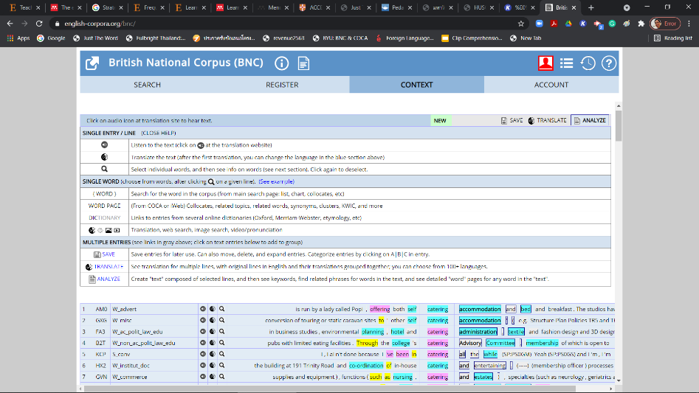**Figure 1.1: An example of concordance lines presentation**

**(BYU-BNC, 2021)**

With this result of a corpus consultant, meanwhile, leaners can play a role of a novel researcher by engaging inductive learning strategies. The learners need to observe, select, analyse, annotate, and interpret what they gained from language data (Huang, 2011, Lee, & Lin, 2019). Likewise, Mukherjee (2006 as cited in Boulton, 2009) pointed out that data driven learning (DDL) promoted an autonomous learner—" *Autonomy can still be engendered where concordances are provided as materials by teachers [...] DDL can still promote learner autonomy even in a less than ideal environment*”.

Vocabulary in specific purposes is probably considered as nuances of language. Then, KWIC in a corpus consultant might be a good evidence for learners and teachers.

**The Study**

2. The context

Simply, as the training was administered during a COVID-19 pandemics, a virtual classroom [Google Class] was used. Hundred ESP vocabulary was selected from brainstorming amongst lecturers of the three courses in semester 2, 2020 academic year at Songkhla Rajabhat University, Thailand. The courses are English for Aviation, English for Advertisement and Public Relations, and English for Hospitality Industry. To validate the sets of vocabulary, those words were tailored and tried out with other 75 students in different universities. All words were calculated. Then, the words were selected and rearranged according to a mean score. Totally, fifty words were used to design an online lesson as presented in (*Appendix A*.). Each set containing 2 related words of the online lesson was approximately 30 – 35 minutes. The learners could access BYU-BNC by themselves at any time.

The pretest was administered in fourth week of the semester and the posttest was done in fourteenth week. The learners spent ten weeks to the self-study.

**Research Methodology**

3. Participants

The participants were English majors enrolled at least two third of ESP courses: (1) English for Aviation, (2) English for Advertisement and Public Relations, and (3) English of Hospitality Industry. They were 31 sophomore learners [26 females, and 5 males] and were 22 third year counterparts [18 females, and 4 males].

4. Data Collection

The pre-test was administered in class and was lasted an hour. The score was confidentially kept. To assure the anonymity, online quizzes [Google form] were used to examine the participants progression along 14 weeks of self-study. The post test was done in week 14.

5. Data Analysis

Descriptive statistics were used to analyse quantitative data. The following table shows mean scores of the pretest, the post-test as well as variances of the mean scores.

**Table 1: Mean scores of the pretest and the post-test (n = 53)**

|  |  |  |  |  |
| --- | --- | --- | --- | --- |
| Pre | | Post | | Variance (%) |
| 1 | S.D. | **2** | S.D. |
| 16.37 | 35.3 | 39.79 | 69.46 | 23.42 (59%) |

Table (1) shows mean scores of the pretest is 16.37 (S.D. 35.3) while the post-test was 39. 79 (S.D. 69.46). This means that learning proficiency of the participants seems positive. The mean scores of the post-test are higher than that of the pretest. By contrast, regarding to *t-stat*, the significant different is 2.01 (Table 2). The *P-value* is 2.01 that is higher than statistically significant .05. Equal variance assumed, then, is used. To interpret the *P-value,* the participants language proficiency seemed stable comparing to the mean score of the pretest and the pos-test.

**Table 2: Variance (n = 53)**

|  |  |  |  |  |  |
| --- | --- | --- | --- | --- | --- |
| n | $$\overline{x}$$ | S.D. | *t* | df | *p-value* |
| 53 | 16.37 | 35.3 | 18.71 | 51 | 2.01** |

*0.05

To answer the research question, the participants probably gain an insight into how to use [downloadable/ searchable] BYU-BNC corpus. They could get a high score of the given words in online lesson [Google class]. Assumably, the participants know how to use a language tools such as English corpus. They can construct their new matter of knowledge about English corpus consultation.

**Conclusion and Limitations**

With a ubiquitous epoch, EFL leaners could search digital information to serve their [learning] requirements. Specifically, English corpus seems one of useful language tools providing correct and appropriate language usage in variety of language registers. The corpus [corpora], then, is essentially necessary for either whoever wants to widen their vocabulary bank or improves their lexical knowledge in accordance with specific purposes.

Although the findings of this current study do not show any statistically significant in language corpus consultant of the participants; they have a new opportunity to become a vocabulary builder. That is, the learners also create and collect a set of English language for purposes. Furthermore, some points of this study might be an example for creating pedagogical activities for both learners and lecturers. For example, a presentation of concordance lines might be downloaded and saved for using certain word usage example. Such the example, the learners can study in several aspects, lexicogrammatical level, for instance.

As for limitations, due to COVID-19 pandemics, data collection procedures were changed from in-class training into an online learning. It caused some drawbacks of statistical significance of the study.

**Section Snippets**

British National corpus (BNC) was established by Oxford University Press from the late twentieth and contain approximately 100 million words with various genres. More information of the BNC can be accessed to www.natcorp.ox.ac.uk. Subsequently, Mark E. Davies, a linguist at Brigham Young University, launched a searchable language data in a form of corpora (Brigham Young University, 2017) available at <http://corpus.byu.edu./bnc/>.

**Acknowledgements**

This work was supported by the Faculty of Humanities and Social Sciences, Songkhla Rajabhat University.

**Author**

Natthika Boonrasameeis a lecturer at the Faculty of Humanities and Social Sciences, Songkhla Rajabhat University. Her research areas are CALL, Communicative skills, and data-driven learning [DDL].

**References**

Brigham Young University [magazine]. (2017). Big Lang at BYU. summer Issue, available at https://magazine.byu.edu/article/big-lang-at-byu/.

British National Corpus. (2021). [online] available at <https://www.english->

corpora.org/bnc/

Boulton, A. (2010). Data-driven learning: on paper, in practice. T. Harris & M. Moreno Jaén. Corpus Linguistics in Language Teaching., Peter Lang, pp.17-52, Linguistic Insights.

Bunnett, G.R. (2013). Using Corpora in the Language Learning Classroom: Corpus Linguistics for Teachers. Michigan University: The University of Michigan.

Csomay, E., & Petrovic, M. (2012). "Yes, your Honor!": A corpus-based study of technical vocabulary in discipline-related movies and TV shows. *System*, 40(2), pp. 305-315.

Cobbs, T., & Boulton, A. (2015). Classroom application of corpus analysis

D. Biber, R. Reppen (Eds.), The Cambridge handbook of corpus linguistics, Cambridge University Press, Cambridge. pp. 478-497

Coxhead, A. (2011). The Academic Word List ten years on: Research and teaching implications. TESOL Quarterly, 45 (2) (2011), pp. 355-362.

Huang, L-S. (2011). Corpus-aided language learning. *ELT Journal*, (65), 4. pp.481-484. Available at https://doi.org/10.1093/elt/ccr031

Lee, P., & Lin, H. (2019). The effect of the inductive and deductive data-driven learning (DDL) on vocabulary acquisition and retention. *System*. 81, pp. 14-25. Available at https://doi.org/10.1016/j.system.2018.12.011.

Lu, M. (2013). Effects of four vocabulary exercises on facilitating learning vocabulary meaning, form, and use. *TESOL Quarterly*, 47 (1), pp. 167-176.

Mitzumoto, A. & Chujo, K. (2016). Who is data-driven learning for? Challenging the monolithic view of its relationship with learning styles. *System*, 61, pp. 55-64

Mukherjee, J. (2006). Corpus Linguistics and Language Pedagogy: The State of the Art – and Beyond. Cited in Boulton, A. (2010). Data-driven learning: on paper, in practice. T. Harris & M. Moreno Jaén. Corpus Linguistics in Language Teaching., Peter Lang, pp.17-52, Linguistic Insights.

Nation, P. (2001). Learning vocabulary in another language. New York: CUP.

Newton, J. (2013). Incidental vocabulary learning in classroom communication

tasks. Language Teaching Research, 17 (2)

Perez-Paredesa, P., Sanchez-Tornelb, M., Alcaraz Caleroc, J.M., & Aguado Jimenez, P. (2011). Tracking learners' actual uses of corpora: Guided vs non-guided corpus consultation, *Computer Assisted Language Learning*, 24 (3), pp. 233-253.

Schmitt, D. (2002). Learning Vocabulary in Another Language. I.S.P. Nation, *ELT*

*Journal*, (56),1 pp. 91– 93, available at <https://doi.org/10.1093/elt/56.1.91>

Yoon, C. (2011). Concordancing in L2 writing class: An overview of research and issues

*English for Academic Purposes*, 10, pp. 130-139. Available at <https://www.sciencedirect.com/science/article/abs/pii/S1475158511000191>

*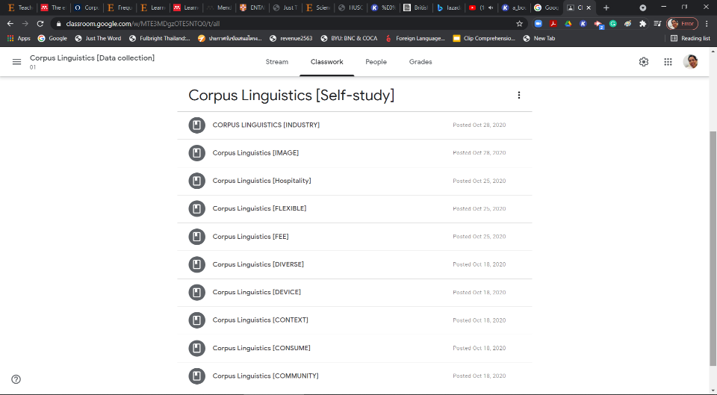****Appendix A*.: An example of an online lesson**

**Figure 2: Online Lesson**

An example of a lesson is available at https://classroom.google.com/c/MTE3MDgzOTE5NTQ0/m/MjAyODIyMTQ5Mjgx/details