Chulalongkorn University Memorial Hall:
Creation and Collection of Collective Memory on the Occasion of the Centenary of Chulalongkorn University

Ratchaneekorn Ratchatakorntrakoon^{1*}
¹ Institute of Thai Studies Chulalongkorn University Phaya Thai Road Pathumwan Bangkok 10330
* e-mail address: Ratchaneekorn.r@chula.ac.th

Abstract
This research aims to study the narratives reproduced in connection with Chulalongkorn University Memorial Hall on the occasion of the centenary of Chulalongkorn University and to analyze the role of such reproduced narratives in recreating the image of Chulalongkorn University. Documentary research was adopted as the primary research method. The research has found that the reproduced narratives can be divided into three groups: 1. the foundation of the first university as the cornerstone of the capital city; 2. the university being a pioneer in teaching and learning management; and 3. the role of Chulalongkorn University in serving society. The theory of collective memory has been adopted to explain the selection and reproduction of such narratives, from which it can be inferred that The Memorial Hall of Chulalongkorn University was used to create an image of Chulalongkorn University as “the serving society university”. This notion is represented through the motto: The honor of Chulalongkorn is the honor of serving the people.
Keywords: Centenary of Chulalongkorn University; Collective Memory; Chulalongkorn University Memory Hall

Introduction
Chulalongkorn University (hereafter, CU), the first official institution of higher learning in Thailand, was founded in 1917 during the reign of King Vajiravudh (Rama VI). On the occasion of the centenary of CU in 2017, Chulalongkorn University Memory Hall (hereafter, CUMH), as CU’s archive, produced many forms of media – photo books, exhibitions, short documentaries and websites – for the celebration and communication the development of CU to the public. These media sources are interesting since they are stories about CU in the past that were specifically selected and presented on this special occasion. This corresponds to the theory of collective memory proposed by Halbwachs (1992:34): “..our conceptions of past are affected by the mental images we employ to solve present problems, so that collective memory is essentially a reconstruction of the past in the light of present.”
According to Halbwachs, stories of the past can be reproduced for a present objective as “collective memory” that has an influence on the image of the story owner. This research examines media produced during the centenary of CU by exploring the following questions: What are narratives about CU that are reproduced by CUMH on the occasion of the centenary of CU? How do the reproduced narratives relate to the collective memory and the image of CU?
Research objectives
1) To study the narratives reproduced in connection with CUMH on the occasion of the centenary of CU.
2) To analyze the role of such reproduced narratives in recreating the image of CU.
Scope of the study
This is qualitative research for which document analysis was adopted as the research method. The researcher selected three sources for this study:
These sources were selected as data for this study because they were produced by CUMH on the occasion of the centenary of CU (March 2016-2018). Furthermore, the researcher decided to use different forms of media – short documentary, photo books and exhibition – to ascertain whether CU reproduce the same historical narratives in different forms.
Research Results
1. Reproduced narratives on the occasion of the centenary of CU
From an analysis of the data, the reproduced narratives can be divided into three groups in line with three analogies: 1) saplings of the Chamchuree tree towards the land of the intellects; 2) growing strong to become a Chamchuri tree and 3) flowers/products of the Chamchuree tree. 1. A short documentary entitled “Hundred years of CU Pride”, which consists of 12 episodes and was released on http://www.cu100.chula.ac.th. 2. The photo book entitled “The Chronicle of CU”, which consists of three volumes following different themes: 1) The Inscription of CU; 2) Photographs of CU; and 3) Record of CU students. 3. The permanent exhibition entitled “A Hundred Stories in Celebration of the Centenary of CU” displayed at Chula Museum and released on http://www.cu100.chula.ac.th.Creating and collecting the narratives of CU using the analogy of the growth of a Chamcuree tree not only stresses the importance of Chamchuree trees as the symbol of CU, but also demonstrates the definite development of CU.
1.1 The foundation of the first university as the cornerstone of the capital city Notwithstanding that the official foundation day of CU was 26 March 1917 in the reign of King Vajiravudh, the three selected texts intentionally return to the duties of King Chulalongkorn (Rama V and King Vajiravudh’s father), especially the reformation of Thailand’s administrative system in 1892 since that linked to the establishment of the Royal Pages’ School, which laid the foundation for the birth of CU. In addition, the intent of King Chulalongkorn regarding equal opportunity to higher education was also stressed: “Members of the royal family; from my children to people in the lowest part of society will be given an equal opportunity to education.” (CU, (n.d.))
Apart from equal opportunity to education, the above quotation underlines the role of the king in the establishment and support of academic institutions. In order to highlight this, the construction of the Headquarters Building, which later was entitled “Maha Chulalongkorn Building”, pictures and King Vajiravudh’s speech on the occasion when he laid the foundation stone of the Headquarters Building on January 3rd, 1915 were displayed: “it will honour and serve as a memorial to King Chulalongkorn, Phra Phiya Maharaj or the Great Beloved King of the Thai nation. It is thus appropriate that we build a grand and permanent monument like this in memory of the King.” (CU, ( n.d.), highlighted the content by researcher)
King Vajiravudh’s speech indicates the aim of the foundation CU was to serve not only as an institute of higher education, but also as a permanent monument to his father. In addition, the role as “the Cornerstone of the Capital City” (CU, ( n.d.)) is also highlighted by being paraphrased as “the pillar as the kingdom”, which means “as the centre for higher studies, producing quality personnel to serve the country” (CU, ( n.d.))
Drawing an analogy between CU and a monument, cornerstone and pillar implies that the foundation of CU is the milestone of Thai social and educational development. Furthermore, such analogies are consistent with the next topic that describes the role of CU in teaching and learning management used to demonstrate how CU performs its duty as “the pillar as the kingdom”.
1.2 The university being a pioneer in teaching and learning management
The first four faculties at CU were the Faculty of Medicine, the Faculty of Public Administration, the Faculty of Engineering and the Faculty of Arts and Science; while now, CU consists of nineteen faculties, fourteen institutes, three colleges and three schools. The increase in the number of academic units shows that CU has passed through many processes of development. In order to underline the role as a pioneer in teaching and learning management, the three selected data sources present narratives about “the first” students, lectures, doctoral programs, as well as new technology in teaching and learning. The 27th to 29th episodes in the exhibition narrated stories about the first female students from 1927 to 1949. Furthermore, photographs of the residential hall for female students was included in Photographs of CU. Narrating the story of female students is evidence to show the intent of King Chulalongkorn regarding “an equal opportunity to education” that every person, even women whose higher educational opportunities were limited due to gender bias, could enter and graduate from CU.
Lectures and educational facilities are contributing factors in teaching and learning achievement, especially in medicine, engineering and science. Apart from lecturers from the royal family, information about the first group of foreign lectures were described in both the 21st episode of the exhibition and Photographs of CU. This shows that inviting foreign experts to share their scientific knowledge was an important process in the early stage of the establishment of higher education. Various educational facilities were shown in the selected data sources, including classrooms, athletic facilities, student clubs and libraries. In order to stress the image of being a pioneer in scientific teaching, images of laboratories with many scientific instruments from the past to the present were included. Figure 1 is a photograph of the first laboratory in the White Building, Faculty of Science in 1929 and the contemporary one in 2017.
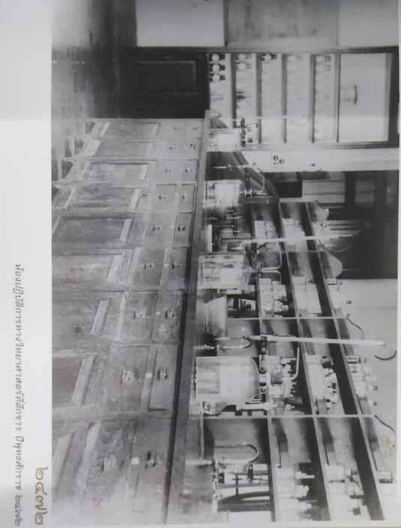 | 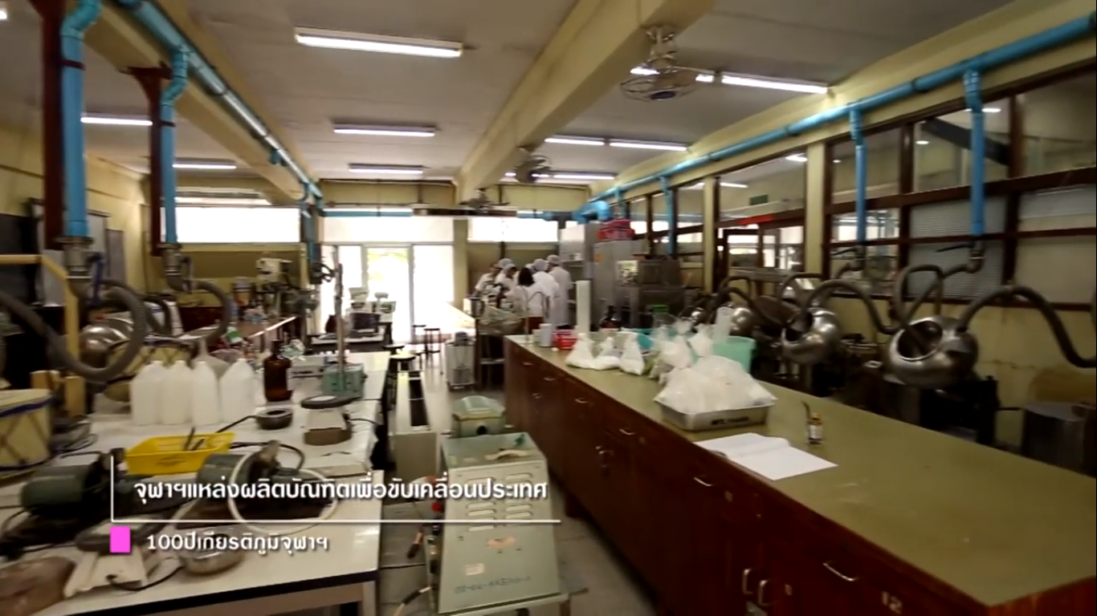
Figure1. Comparison of the first laboratory in the White Building in 1929 (CU, 2017: 49) and the contemporary laboratory in 2017 (CU, March 25, 2017: online).
In line with the changing world in which computer systems take part in every organization, the data shows how CU has not only applied, but also developed computer systems to facilitate teaching and learning. Episodes 50 to 54 of the exhibition presented information about the computer system at CU: computer science programs; the application of the computing system to student registration; the beginning of electronic libraries which were Thailand’s first working unit connected to the internet; and the CU Write Program. Such information reflects that CU has expanded the scope of computer science knowledge from teaching and learning management to public use.
1.3. The role of CU in serving society
The roles of CU in serving society can be classified into four groups: 1) the involvement in social and political movements; 2) the use of knowledge to solve problems; 3) conservation of arts and cultures; and 4) the dissemination of knowledge to society. The selected data show that CU has continually undertaken such roles from the past to the present.
Many episodes of the exhibition show how CU students have participated in many milestones of Thailand’s political history, such as the return of Thai territory in French Indochina in 1940 (ep.55) ; the coup d’état to remove the civilian government in 1947 (ep.57); the campaign against buying Japanese merchandise in 1971 (ep. 61); the 14 October 1973 political uprising. Moreover, the 6th episode of the short documentary presented the role of CU on Black May in 1992. Apart from the involvement of student groups, the story of an outstanding student, Chitra Phumisak, whose works demonstrated opposition to dictatorship and presented an ideology for the masses, was mentioned in the 59th episode of the exhibition.
Disaster, environmental problems and pandemic are serious problems which require specific knowledge and experience to solve. Many units at CU, such as the faculties of Engineering, Medicine and Veterinary Science, have cooperated with government and private sectors with knowledge support. The 7th episode of the short documentary showed that the transcription of genetic code was used to prevent an outbreak of Bird Flu, while the 66th episode of the exhibition showed the role in providing solutions for the tsunami in 2004.
CU has undertaken many events to conserve arts and culture that are used as an indicator of the civilization of the country. The creation of National Thai Language Day on 29 July 1962 and the performance of HRH Princess Maha Chakri Sirindhorn in the Peepaataya’ Dukdumban Orchestra are mentioned in all the selected data. This not only underscores the role of CU in conserving Thai language and music, but also shows the duty of King Bhumibol (Rama IX) and his daughter to preserving arts and culture.
CU disseminates knowledge to society in the form of research, innovation and museums located in CU and other campuses, and information is presented covering all areas, such as the Museum of Natural Medicine, the Vach Vidyavaddhana Museum, the Museum of Imaging and Printing Technology, the Museum of the Human Body, the Museum of Geology, the Museum of Natural History, the Tai-Kadai Museum. These museums are open to the public without admission fee and accessible everyone.
Above analysis indicates that CU not only has involved in social change but also made the considerable effort into participating in all areas of the country development. This topic is obviously accentuated in selected data which further discussed in next part.
2. Creating and of collective memories on the occasion of the centenary and the new image of CU
Drawing an analogy with the Chamchuree tree is the good approach to convey the development of CU from the foundation to role of CU in the present which is underlined. The exhibition and the short documentary consisting of definite number of episodes which can be clearly calculated are the prime example to show this point. Both media present the role of CU in serving society in the equivalent rate that are fifty-one and fifty percent which represent with the grey parts. Thirty-three percent of exhibition describes the learning and teaching management which represents with orange part, while only twenty-five percent in short documentary. The percentage of the narratives about the foundation of CU representing with the blue parts is only sixteen in the exhibition and twenty-five in short documentary.
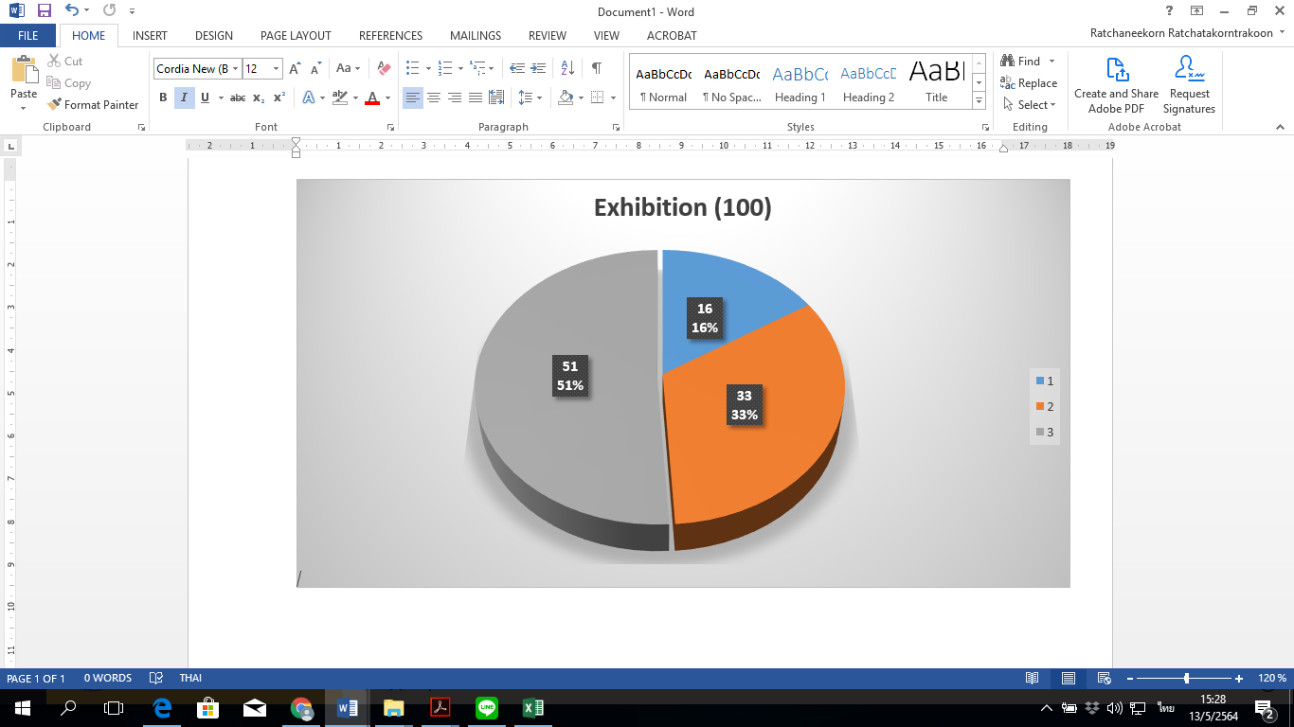 | 
Figure 2 Comparison of the percentage of three groups of reproduced narratives between exhibition and short documentary
The first volume of the Chronicle of CU which focuses on the foundation of CU, also presents the role of CU in serving society like the campaign against Japanese merchandise presented in the 61st episode of the short documentary. Furthermore, the third volume, The Record of CU Students, demonstrates the role of CU in the great flood in Bangkok in 2011, which is similar to the 67th episode of the short documentary.
Apart from the description of social service activities, the three sources show a reinterpretation of the traditional football between CU and Thammasat University in the aspect of social service, rather than an entertainment or sports activity:
The most important contribution of the traditional football is not the result of the football competition, but is the unity of students from two institutes that they have created social benefits together. (10th episode of the short documentary)
In the morning of the traditional football match, both CU and Thammasat University students undertake voluntary services such as cleaning streets, planting trees. (The Record of CU Students, p.167)
Also, the voluntary activities instill a public spirit in the freshmen and make them think about the public good. (30th episode of the exhibition)
The large number of episodes mentioning the role of CU in serving society, the reproduction of the narrative about the role of CU in serving society, as well as the reinterpretation of the traditional football, indicate that all the narratives were intentionally selected and reproduced to communicate the image of CU as the serving society university. This is shown in the introduction of the short documentary:
Throughout the past 100 years Chula graduates have made continuous efforts to serve the people by applying their knowledge and expertise for the betterment of their society and contributing towards the development of the nation in all relevant areas.
Given the university founder, Rama VI, and the primary objective of the formation of the university, CU has had an image of a university that has had a strong bond with the royal family. On the occasion of its 75th anniversary in 1992, CU published a book entitled “A Pillar of The Kingdom: A Birth of Chulalongkorn University”. This book shines a light on this image with the description of the contribution of Rama V and VI, as well as many members of the royal family since the foundation of the university.
Within the concept of collective memory, CUMH as the university archives used the centenary of the CU as an occasion to create the image of CU as “the serving society university”, along with an image of the university that has had a strong bond with the royal family. Hence, many narratives about the past were collected, reproduced and rearranged in forms of modern media that is easy to access and disseminate. The celebration of the centenary was used as a special occasion to construct the image of CU in the present and establish the role of CU in the next century. This notion is represented through the motto: The honor of Chulalongkorn is the honor of serving the people, which is frequently quoted in many social service activities. Additionally, this notion is presented in concrete form as the foundation of “The CU Centenary Park” considered a gift from CU to society.
Conclusion and discussion
This research aims to study the narratives reproduced in connection with CUMH on the occasion of the centenary of CU and to analyze the role of such reproduced narratives in recreating the image of CU. The research has found that the reproduced narratives can be divided into three groups: 1. the foundation of the first university as the cornerstone of the capital city; 2. the university as a pioneer in teaching and learning management; and 3. the role of CU in serving society. The theory of collective memory was adopted to explain the selection and reproduction of such narratives, from which it can be inferred that such images were used to recreate the image of CU as “the serving society university”.
As the CU’s archive, CUMH shoulders the responsibility to maintain, as well as to publish, the history of CU. The centenary of CU was both a celebration and the chance to present the development of this university from its earliest days to the contribution it has made towards the betterment of Thai society up to the present. Selecting a website as a platform to disseminate the produced media, despite the information having been shown in the CU museum, appears to imply that the target audience was not just CU students and staff, but society in general. This indicates that the information produced on the occasion of the centenary was used to create and communicate the image of CU as “the serving society university” to society.
Reference
CU. (1994). A Pillar of the Kingdom: A Birth of Chulalongkorn University. Bangkok: CU.
CU. (n.d.) “A Hundred Stories in Celebration of the Centenary of CU” retrieved from http://www.cu100.chula.ac.th/%e0%b8%a3%e0%b9%89%e0%b8%ad%e0%b8 %a2%e0%b9%80%e0%b8%a3%e0%b8%b7%e0%b9%88%e0%b8%ad%e0%b8 %87%e0%b8%a3%e0%b8%b2%e0%b8%a7/
CU. (n.d.) “Hundred year of CU Pride” retrieved from http://www.cu100.chula.ac.th/100- %e0%b8%9b%e0%b8%b5- %e0%b9%80%e0%b8%81%e0%b8%b5%e0%b8%a2%e0%b8%a3%e0%b8%95%e0%b8% b4%e0%b8%a0%e0%b8%b9%e0%b8%a1%e0%b8%b4%e0%b8%88%e0%b8%b8%e0%b 8%ac%e0%b8%b2%e0%b8%af
CU. (2017). The Chronicle of CU, [the first volume]. Bangkok: CU.
CU. (2018). The Chronicle of CU, Photographs of CU. Bangkok: CU.
CU. (2017). The Chronicle of CU, the Record of CU Students. Bangkok: CU.
Maurice Halbwach, edited, translated and with an introduction by Lewis A. Coser. (1992). On Collective Memory. Chicago: The Chicago University Press.

This paper is a part of the research project entitled “Implementation of Virtual Reality of Memorial Hall of Chulalongkorn University to demonstrate the history via 5G and beyond Network in Chulalongkorn University” which is funded by Thailand Science Research and Innovation (TSRI) , fundamental fund program 2020.

